Permaculture originated from the term Permanent Agriculture to emphasis the relationship between people and their environment. It was later adjusted to come from permanent culture to also incorporate social aspects of the agriculture system.

Permaculture is a philosophy of working with, rather than against nature; of protracted and thoughtful observation rather than protracted and thoughtless labour; and of looking at plants and animals in all their functions, rather than treating any area as a single product system.

— *Bill Mollison, often referred to as the father of Permaculture.*

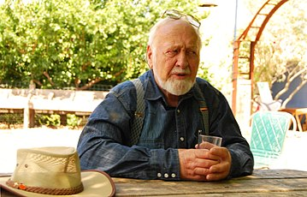

## Foundational ethics

The ethics on which permaculture builds are:

* Earth care: Provision for all life systems to continue and multiply.
* People care: Provision for people to access those resources necessary for their existence.
* Fair share: Setting limits to population and consumption so that people do not take more than what is needed. By governing our own needs, we can set resources aside to further the above principles. This principle is also described as *share the surplus*.

<https://www.youtube.com/watch?v=ss1BjW2kSNs>

<div class="column" style="padding: 10px; height: 300px; width: 50%; text-align: center;">

<div class="column" style="float: left; padding: 10px; height: 300px; width: 50%; text-align: center;">